Assignment-1

.

1. The intercept() is the value of when we make inc zero, i.e. the value is

-124.84. The sign is negative as the when the income of individuals is zero their consumption equals -124.84, which implies that the consumer borrows the amount 124.84.

b. The predicted consumption when family income is $30,000:

cons= -124.84+(0.853*30000) = 25465.16

c.

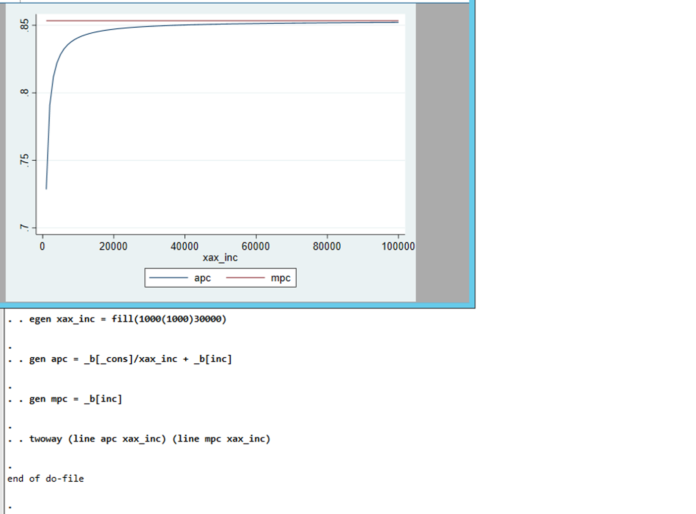

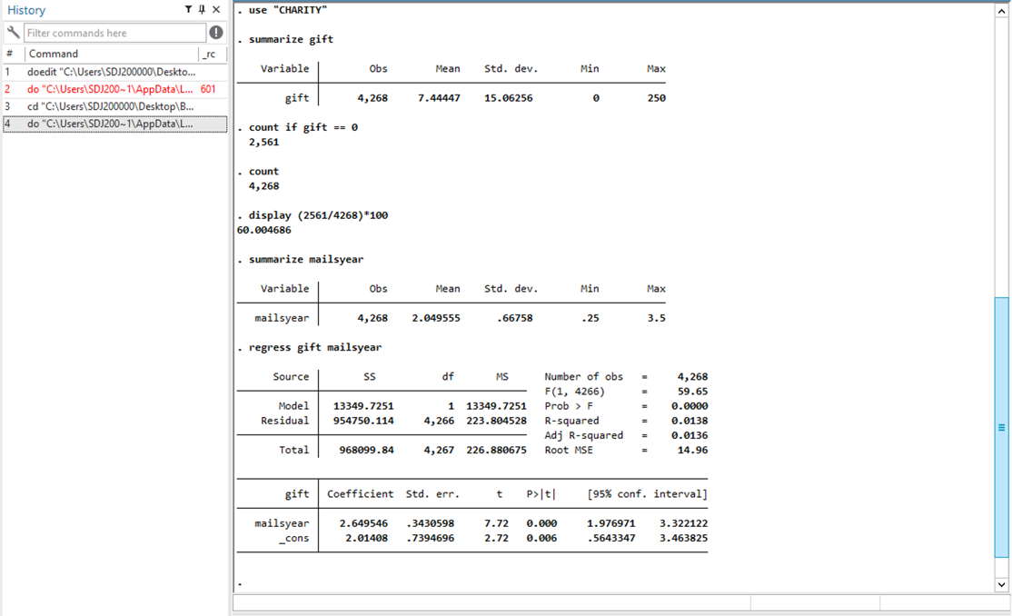

a.

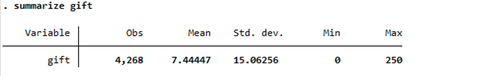

The average gift in sample of 4.268 people is 7.44 Dutch guilders. Out of 4,268 respondents 2561 didn’t give which is approximately 60 percent of the total people.

1. Around 2.05 mailings are sent out annually on average. The minimum value is.25 and the maximum value is 3.5, indicating that someone has been subscribed to the mailing list for at least four years.
2. gift= 2.01 + 2.65mailsyear

n=4,268 R^2=0.318

1. According to the slope coefficient from part (iii), each mailing per year is related to, or maybe even "causes," an extra 2.65 guilders on average. The expected profit from each mailing is therefore calculated to be 1.65 guilders if each mailing has a cost of one guilder. However, this is merely the average. Some mailings receive no contributions or receive a contribution that is significantly less than the cost of mailing; other mailings receive much more than the cost of mailing.
2. The sample's smallest mailsyear is 0.25, so the smallest predicted gift value is 2.01 + 2.65*(.25) = 2.67. The smallest predicted value is about two, even when we consider the entire population, where some individuals have not received any mailings. Therefore, we can never predict zero charitable gifts using this estimated equation.
3. 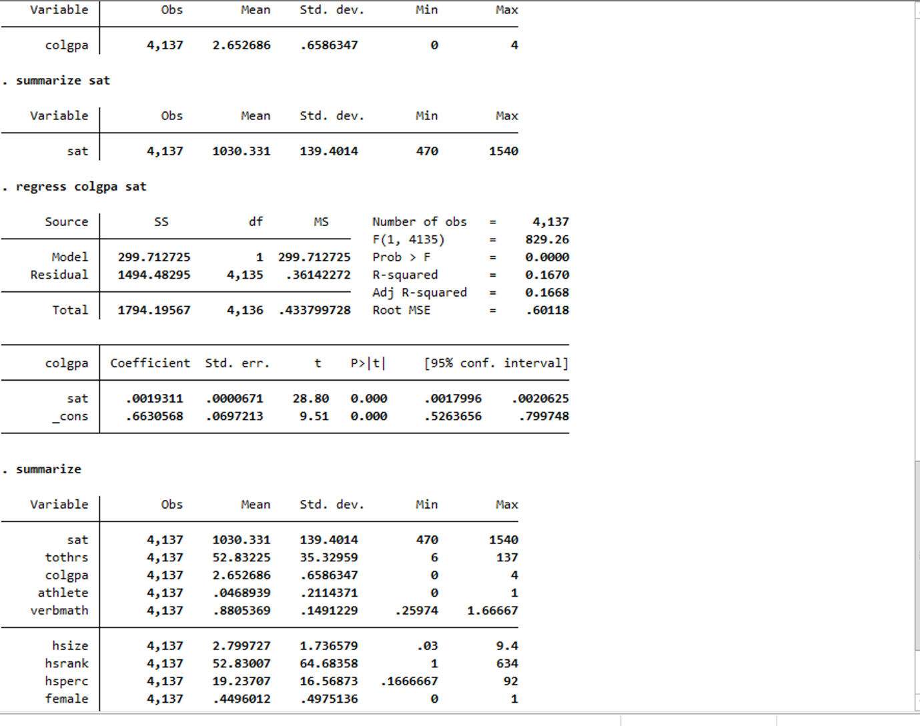
   1. Hsperc is the percentile in the high school graduating class; for example, , If the student is in the top 5% of the class, hsperc = 5. This means that the higher the hsperc, the lower his ranking, and thus the expected college GPA.

Predicted college GPA (hsperc=20, sat=1050):

= 1.392 – 0.0135(20) + 0.00148(1050)

= 1.392 – 0.27 + 1.554

= 2.676

* 1. Because both students graduated from high school in the same percentile, the SAT score will be the most important factor influencing GPA. Because Student A's SAT score is 140 points more than Student B's, Student A's college GPA will be higher than Student B's college GPA by:

0.00148*140=0.2072

* 1. , as hsperc is fixed

We want to find , such that =0.5.

But we won’t be able to find it by solving:

=0.5

0.5=

∆sat= 337.84

To get =0.5, ∆sat should be equal to 337.84. The SD of SAT is approximately 139 implying that we require about two and a half SD in SAT Score.

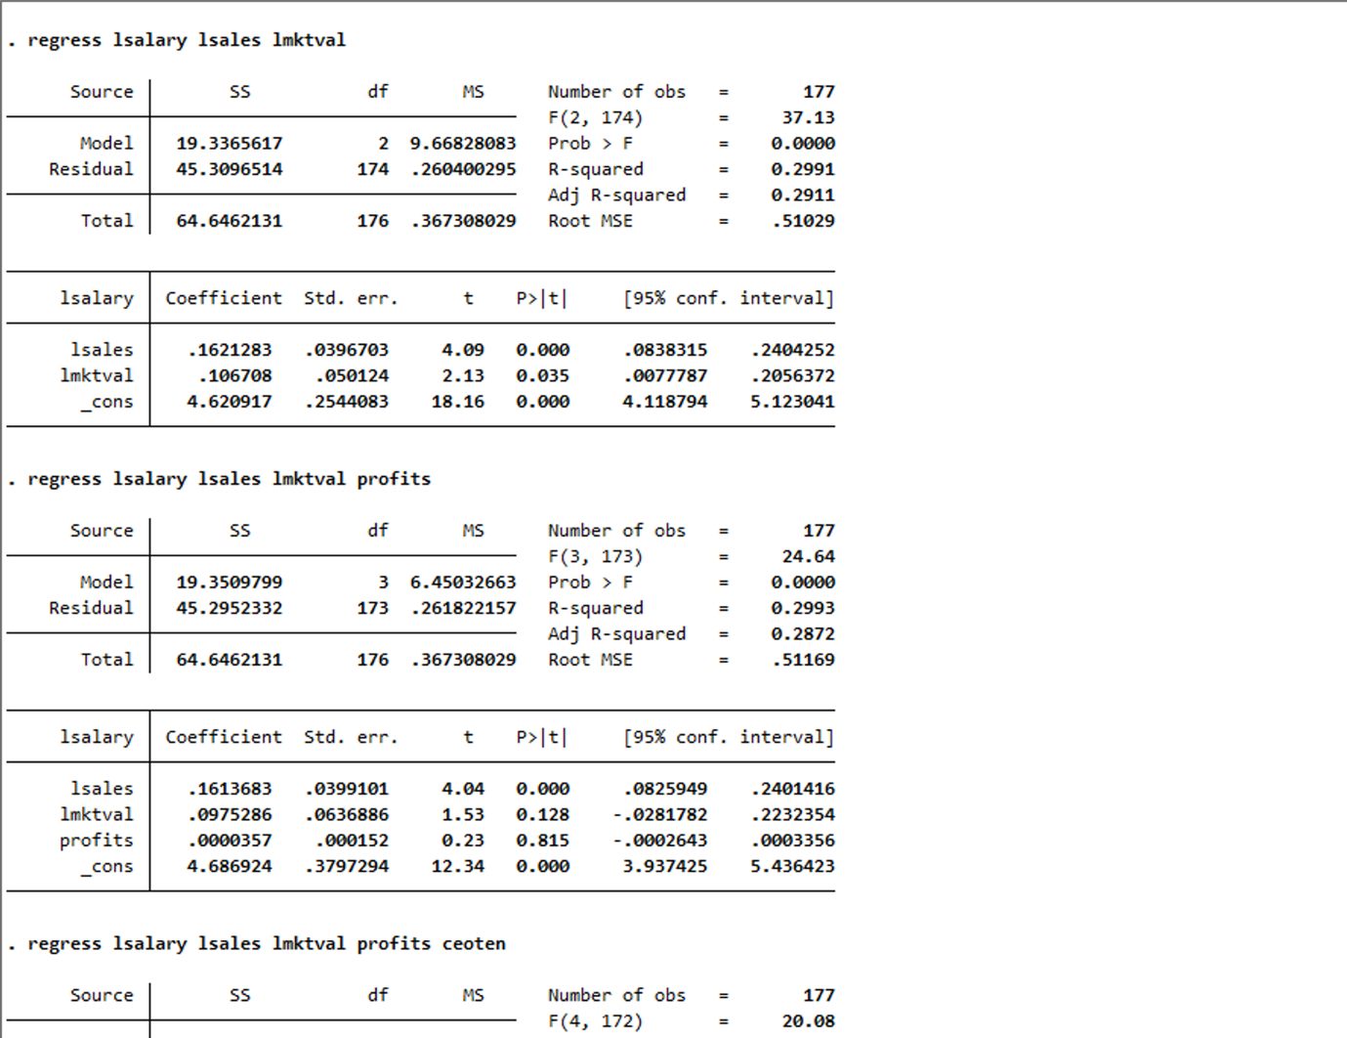

* 1. We require a constant elasticity model, which is a model with linear elasticities. So model will be:

Log(salary) = 0 + β1log(Sales) + β2log(mktval)+ µ

lsalary = 4.62 + 0.162 lsales + 0.107lmktval+µ

n=177, = 0.2991

* 1. Profits may be negative. The value of the log of a negative number is undefined.

When we add profits to the model, we get:

lsalary=4.687+0.161 lsales + 0.0975lmktval + 0.000profits+µ

R-square=0.30, indicating that only 30% of the variation in log (salary).

* 1. Adding ceoten we get:

lsalary = 4.558 + 0.162lsales + 0.102lmktval + 0.000profits + 0.012 ceoten + µ

Holding other factors constant if we increase ceo tenure by 1 year the salary will increase by 1%.

* 1. The sample correlation coefficient is 0.777, indicating a strong relationship between lmktval and profits.

The independent effect of lmktval or profits on lsalary is difficult to estimate.

1. 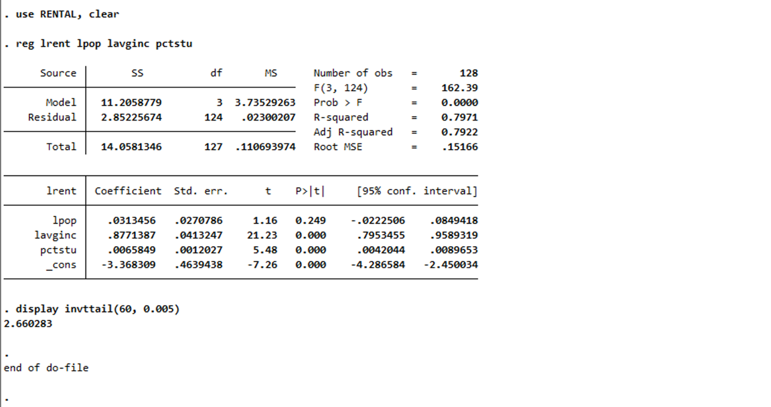
   1. H0: β3= 0

H1: β3 ≠0

* 1. 1 will have a positive sign. This is because as the population grows, so will the demand for housing. This will result in an increase in rent as demand rises. 2 will have a positive sign. This is because as the average income rises, so will the demand for housing, driving up the price. Rent will rise as a result of this.
  2. The statement is untrue because elasticity is represented by the coefficient of log(pop), 0.066, in the equation. As a result, a 10% increase in population will result in a 0.66*(10%)=0.66% increase in rent.

Therefore, "a 10% increase in population increases rent by 0.66%" will be the correct statement.

* 1. We will calculate the t-stat for 3:

=0.0056/0.0017 =3.29

t-stat=3.29

The critical value for a two-tailed test at a 1% level will now be determined.

We will find df= 64-3-1= 60

We will use the following command to find the critical value at 1% level:

‘display invttail(60, 0.005)’

Critical value = 2.660283

Therefore, we can conclude that 3 is not equal to 0 because t-stat is greater than the critical value.

1. 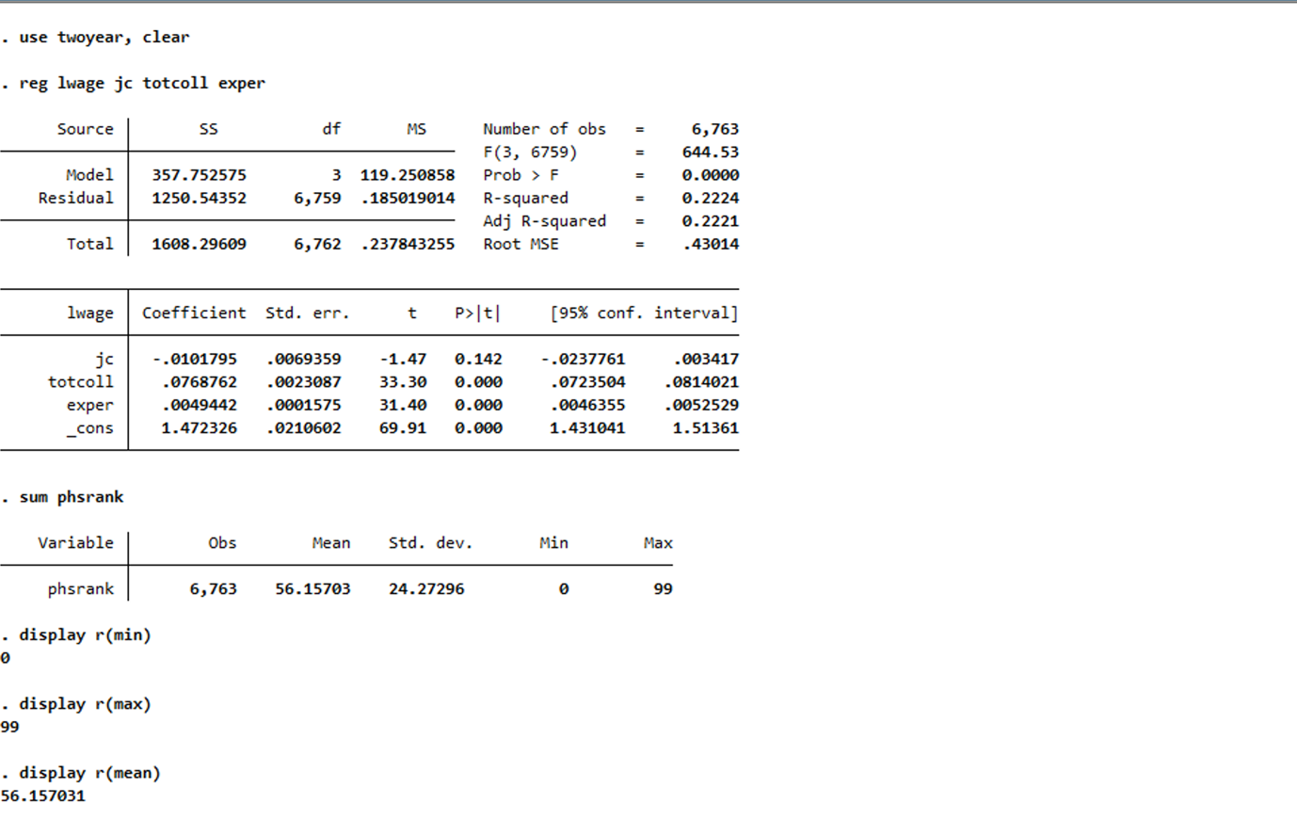

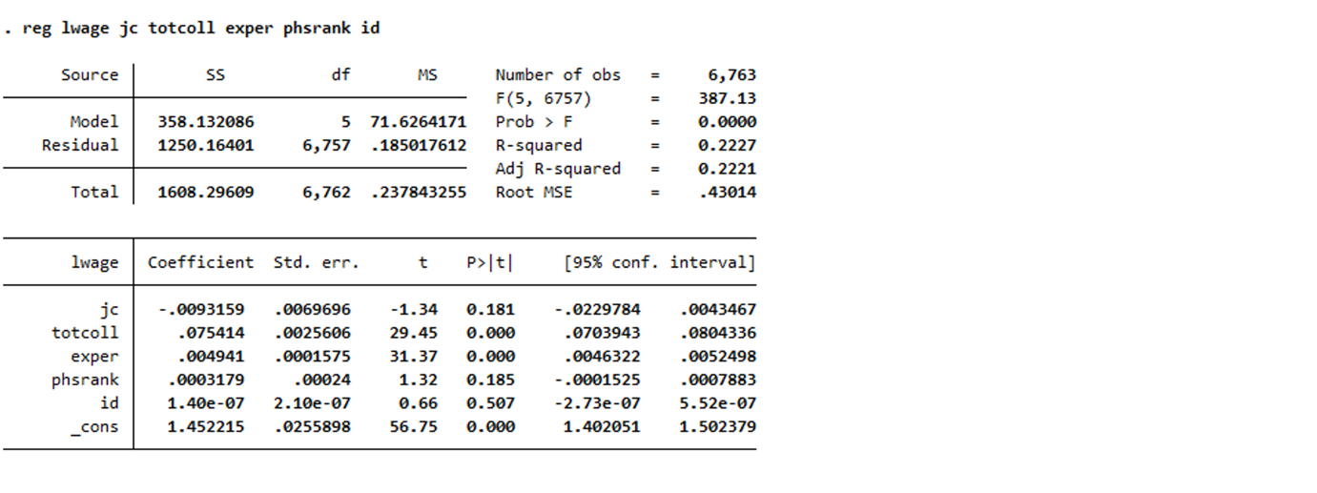

* 1. Running the regression model, we get

Lwage= 1.47 - 0.01jc + 0.077 totcoll + 0.005exper+µ

N=6763, R-square: 0.224

* 1. After running summarize phsrank, we get:

Smallest: 0

Largest: 99

Average: 56.16

* 1. After adding phsrank we get:

Lwage= 1.46 - 0.009jc + 0.075totcoll + 0.005exper + 0.000phsrank + µ

N=6763, R-squared: 0.223

* 1. The conclusion regarding the returns to two and four year colleges is unaffected significantly by the addition of phsrank to the model. Jc's coefficient shifts from -0.01 to -0.009 in this equation. Totcoll's coefficient decreases from 0.077 to 0.075.
  2. The ID number is represented by the variable id in the data set. Even if we include ID in the model, since wage is not dependent on the ID number, we anticipate it to be statistically insignificant.

1. 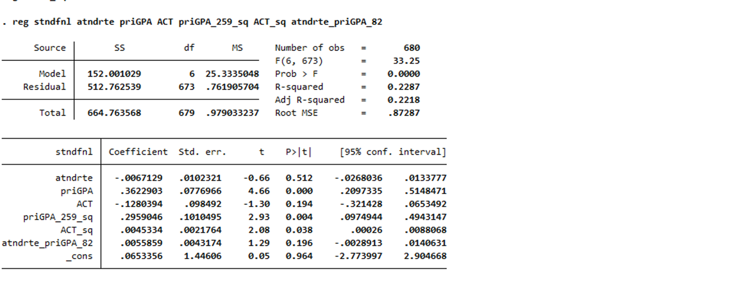

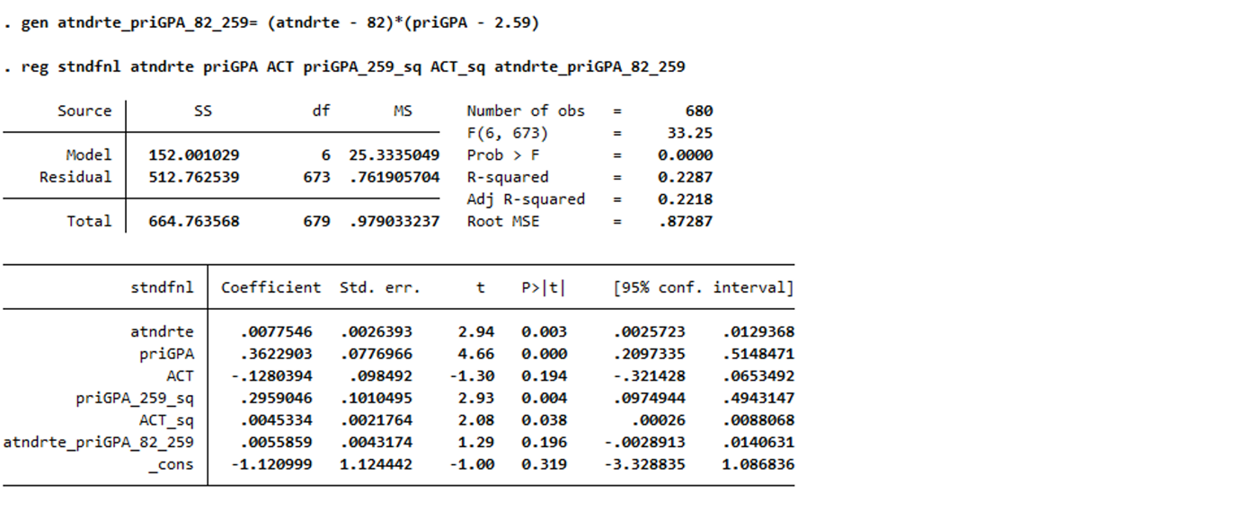

* 1. stndfnl = b0 + b1atndrte + b2priGPA + b3ACT + b4priGPA^2 + b5ACT^2 + b5ACT^2 + b6priGPA.atndrte + u

dstdfnl/dpriGPA = 0+0+b2+2b4+priGPA+0+b6atndrte

dstdfnl/dpriGPA = b2+2b4+priGPA+b6atndrte

Which implies that the argument is correct.

* 1. The partial effect of priGPA on stndfnl with above equation,

Dstndfnl/DpriGPA = -1.63 + 2(0.296) *priGPA +0.0056*atndrte

Mean(atndrte) = 82, Mean(priGPA) = 2.59

Substitute atndrte = 0.82 (since its attendance rate) and priGPA = 2.59

dstndfnl/dpriGPA = -1.63 + 2*(0.296)* 2.59 +0.0056*82 = 0.3624

The standard final exam score will therefore change by 0.3624 standard deviations for every 1 point increase in GPA.

* 1. Since the t-value is higher than the critical value, θ2 equals 0.3622 (SE = 0.0776), which is significant at the 5% level. A GPA increase of 1 unit will result in a 0.3622 increase in the final exam score on the standardized test.
  2. Since the t-value is higher than the critical value, both b1 and θ2 equal 0.007 (SE = 0.0026) and 0.3622 (SE = 0.07769), respectively, and are significant at the 5% level.

The partial effect of GPA on stndfnl at atndrte = 82 is 0.007

The partial effect of atndrte on stndfnl at GPA = 2.59 is 0.36

**Assignment-1 Code**

/*Q1*/

use "SAVING", clear

. reg cons inc

. estimates store m1, title (model 1)

. egen xax_inc = fill(1000(1000)30000)

. gen apc = _b[_cons]/xax_inc + _b[inc]

. gen mpc = _b[inc]

. twoway (line apc xax_inc) (line mpc xax_inc)

/*Q2*/

clear

use "CHARITY"

summarize gift

count if gift == 0

count

display (2561/4268)*100

summarize mailsyear

regress gift mailsyear

/*Q3*/

clear

use GPA2

summarize colgpa

summarize sat

regress colgpa sat

summarize

/*Q4*/

use ceosal2,clear

regress lsalary lsales lmktval

regress lsalary lsales lmktval profits

regress lsalary lsales lmktval profits ceoten

correlate lmktval profits

/*Q5*/

use RENTAL, clear

reg lrent lpop lavginc pctstu

display invttail(60, 0.005)

/*Q6*/

use twoyear, clear

reg lwage jc totcoll exper

sum phsrank

display r(min)

display r(max)

display r(mean)

reg lwage jc totcoll exper phsrank id

/*Q7*/

use Attend,clear

gen priGPA_259_sq = (priGPA - 2.59)^2

gen atndrte_priGPA_82 = (atndrte - 82)*priGPA

gen ACT_sq = ACT^2

reg stndfnl atndrte priGPA ACT priGPA_259_sq ACT_sq atndrte_priGPA_82

gen atndrte_priGPA_82_259= (atndrte - 82)*(priGPA - 2.59)

reg stndfnl atndrte priGPA ACT priGPA_259_sq ACT_sq atndrte_priGPA_82_259